Day 2 — Retrieval Augmented Generation (RAG)
Duration: 4 Hours
Lab Title: Build a Retrieval-Augmented Generation (RAG) Application with Azure AI Foundry

Lab Objectives
By the end of this lab, you will be able to:
- Deploy a GPT model in Azure AI Foundry.
- Apply basic prompt engineering techniques.
- Create an Azure AI Search index.
- Configure a knowledge source.
- Connect the knowledge source to an AI agent.
- Test a RAG-based application through the UI.

Lab Architecture
The solution you will build:
Documents → Azure AI Search → Knowledge Source → AI Agent → GPT Model → User
The GPT model generates the answer, while Azure AI Search retrieves relevant information from your documents.

Prerequisites
Make sure the following resources are available:
Resource | Purpose
Azure Subscription | Create and manage resources
Azure AI Foundry Project | Build and test AI solutions
GPT Model | Generate responses
Azure AI Search | Store and retrieve indexed content
Storage Account | Store knowledge documents
VM / VS Code | Optional development environment

Lab 1 — Deploy GPT Model

Step 1: Open Azure AI Foundry
- Sign in to the Azure Portal.
- Open Azure AI Foundry.
- Open the AI Foundry project provided for the lab.
- From the left navigation pane, select Models + endpoints.
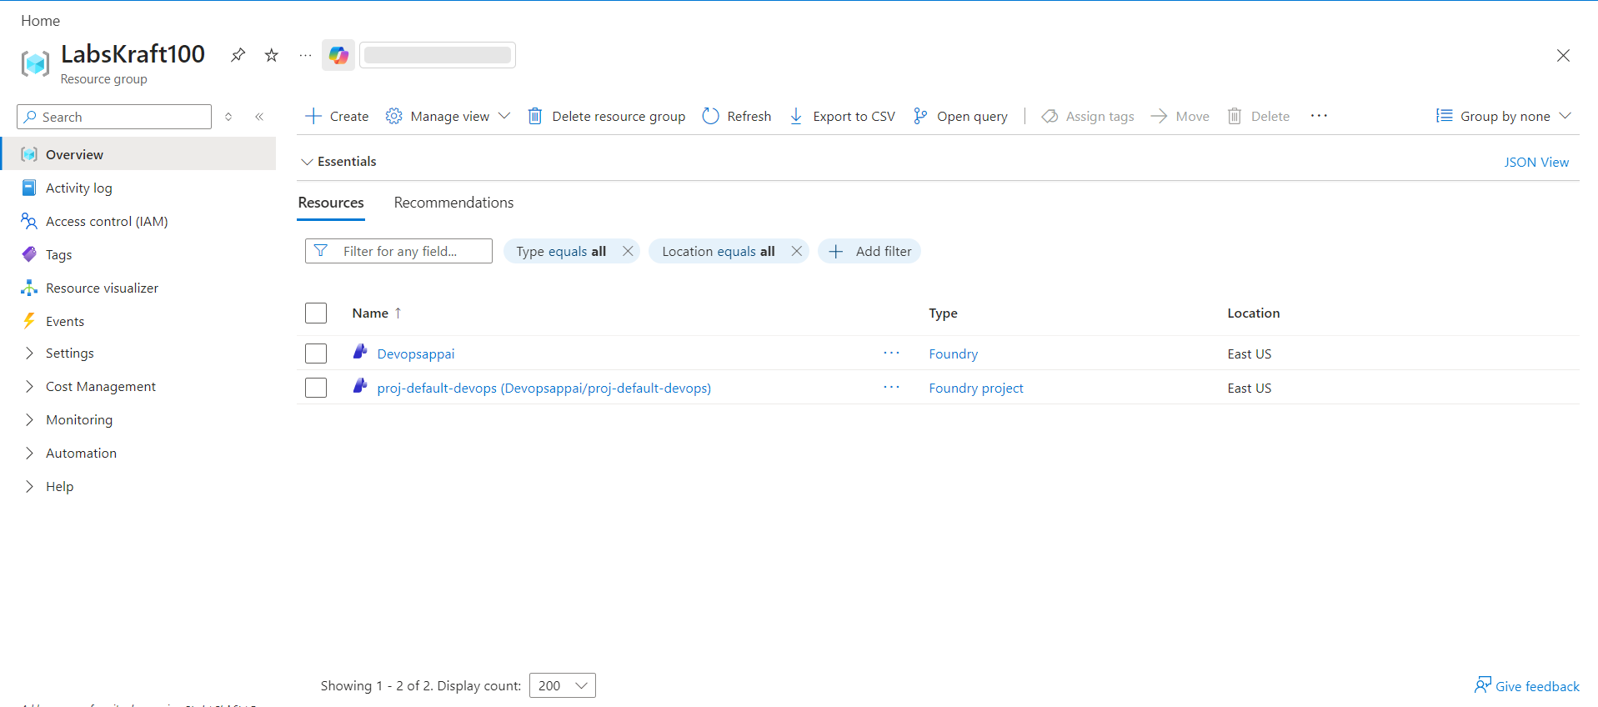
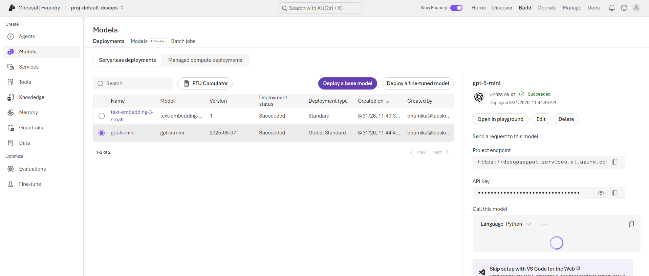

Step 2: Deploy a GPT Model
- Select + Deploy model.
- Choose Deploy base model.
- Search for an available GPT model, such as the GPT model assigned for your lab.
- Select the model.
- Configure the deployment:
  - Deployment name: gpt-5-mini
  - Keep the default supported configuration unless instructed otherwise.
- Select Deploy.
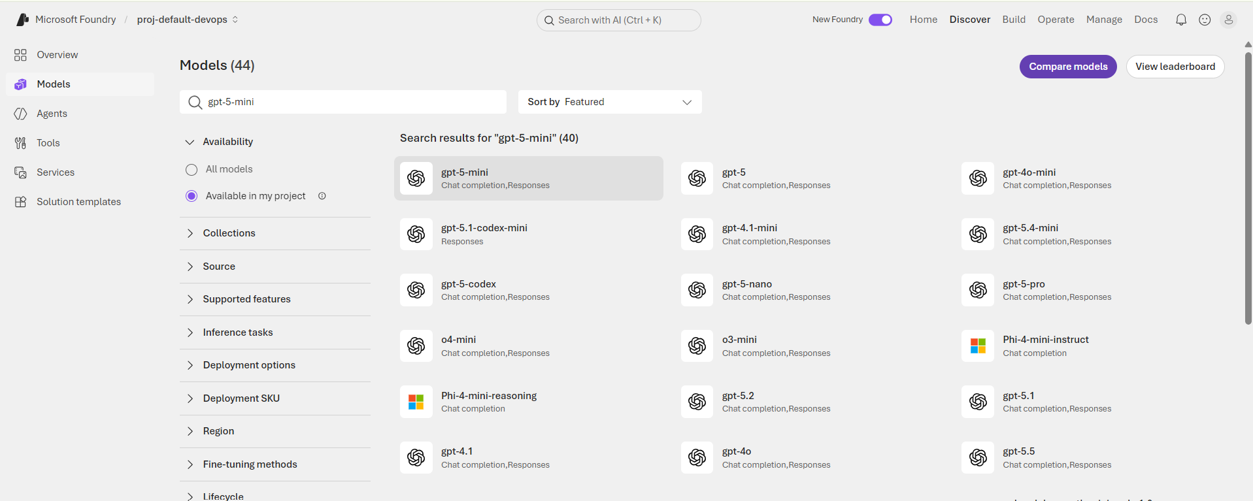
Wait until the deployment status shows Succeeded.

Verify
Open the deployed model and confirm:
- Model status: Succeeded
- Deployment name is visible.
- The model can be selected from your project.

Lab 2 — Prompt Engineering
Before building RAG, test how prompting affects the model's response.

Step 1: Open Playground
- In Azure AI Foundry, open Playgrounds.
- Select Chat playground.
- Select your deployed GPT model.
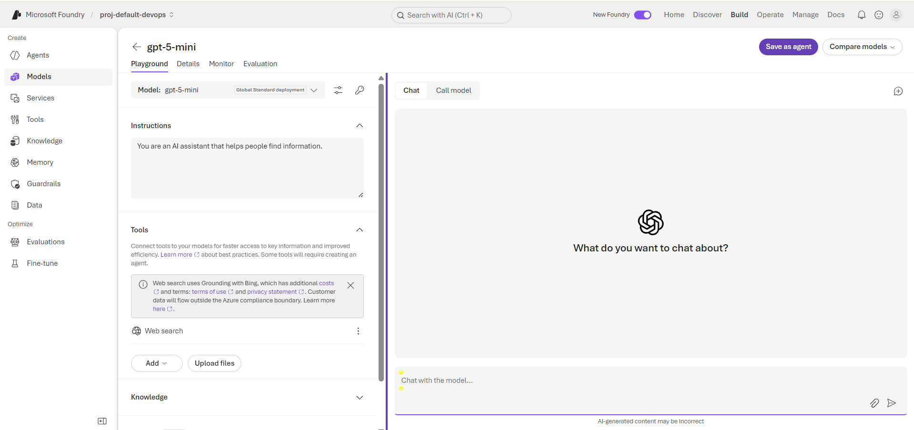

Step 2: Test a Basic Prompt
Enter:
Explain Retrieval Augmented Generation.
Observe the response.
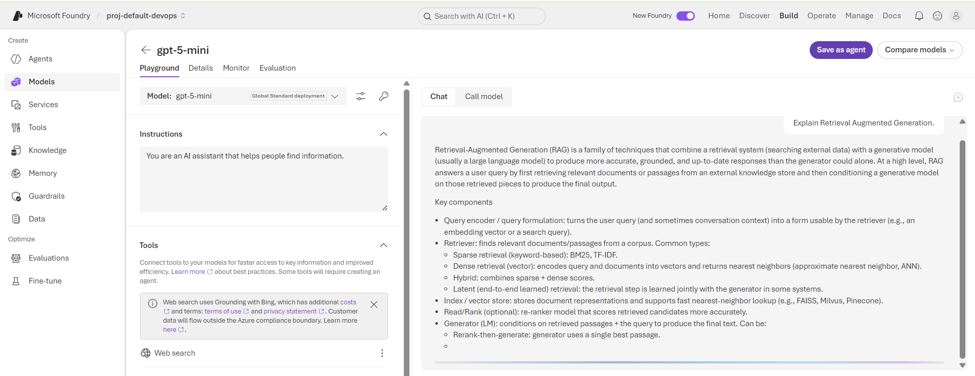
Now provide a more structured prompt:
You are an Azure AI instructor. Explain Retrieval Augmented Generation to a beginner in simple terms. Use a short example and explain the role of Azure AI Search.
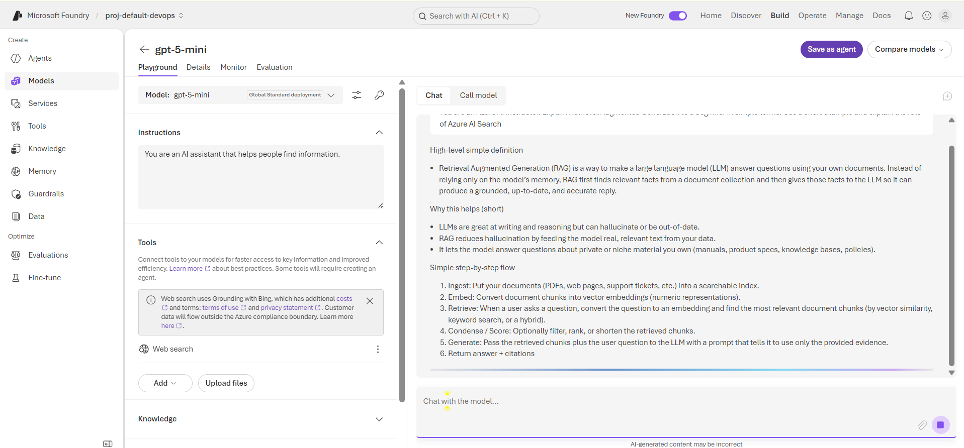
Compare the two responses.

Step 3: Add System Instructions
In the System message / Instructions section, enter:
You are an Azure AI assistant. Answer questions clearly and accurately. If information is not available in the provided knowledge, state that you do not have enough information. Do not invent facts.
Send another question and observe the difference.
Key takeaway:
System instructions control the assistant's behavior, while user prompts provide the specific task or question.

Lab 3 — Create Azure AI Search
Azure AI Search will be used to retrieve relevant information from the knowledge documents.

Step 1: Open Azure Portal
- Go to Azure Portal.
- Select Create a resource.
- Search for Azure AI Search.
- Select Create.
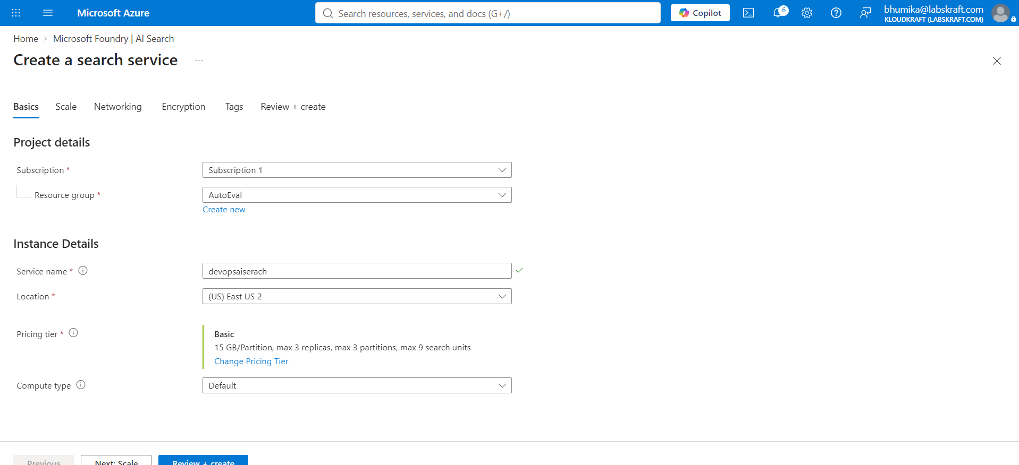

Step 2: Configure Search Service
Provide:
- Subscription: Your lab subscription
- Resource Group: Your lab resource group
- Service name: search-rag-<unique-name>
- Region: Same region as your AI resources where possible
- Pricing tier: Basic

Select Review + create → Create.
Wait for deployment to complete.

Lab 4 — Upload Knowledge Documents
You need documents that the RAG application can search.

Step 1: Open Storage Account
- Open your Storage Account.
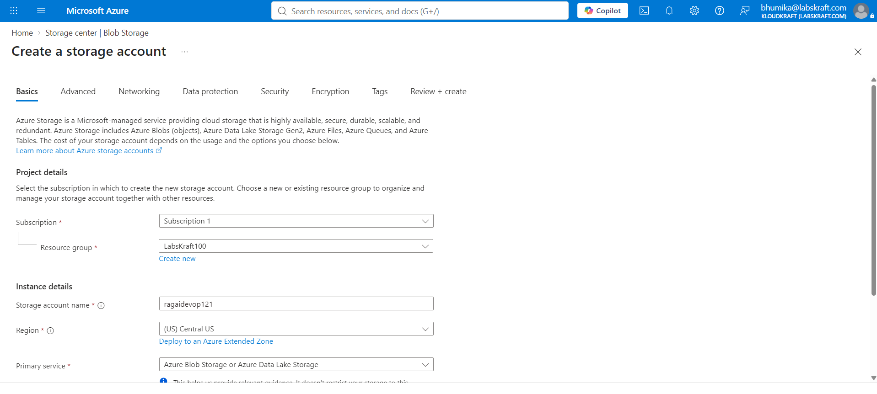
- Select Containers.
- Create a container:
knowledge
- Open the container.
- Select Upload.
- Upload the provided knowledge document(s).
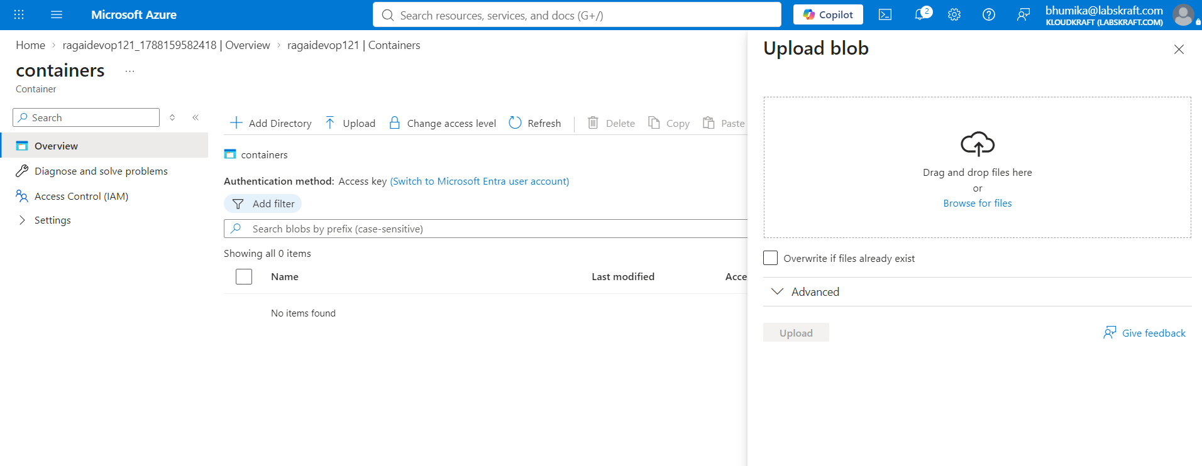
For example:
- Azure_AI_Foundry.pdf
- RAG_Guide.pdf
- Azure_Services.pdf
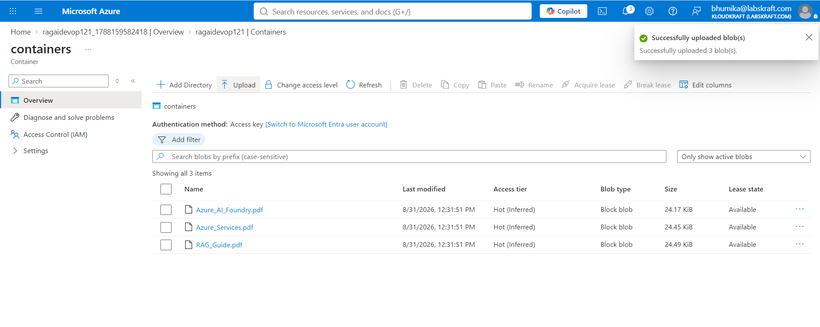

Lab 5 — Create a Knowledge Source
Now connect your documents to the search service.

Step 1: Open Azure AI Search
- Open your Azure AI Search resource.
- Navigate to the data/indexing or Import data experience.
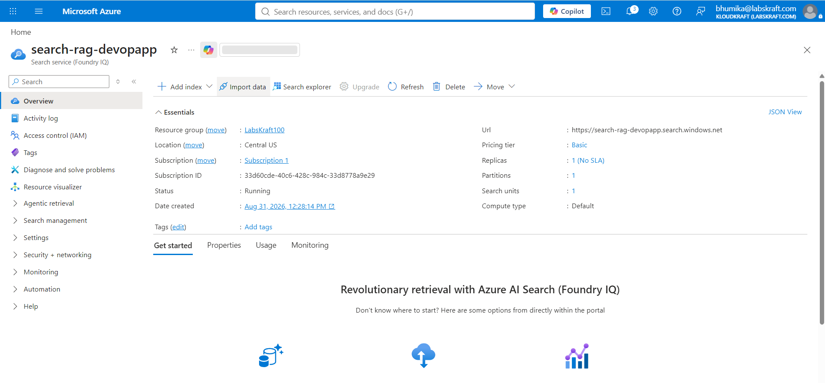
- Select the storage account as the data source.
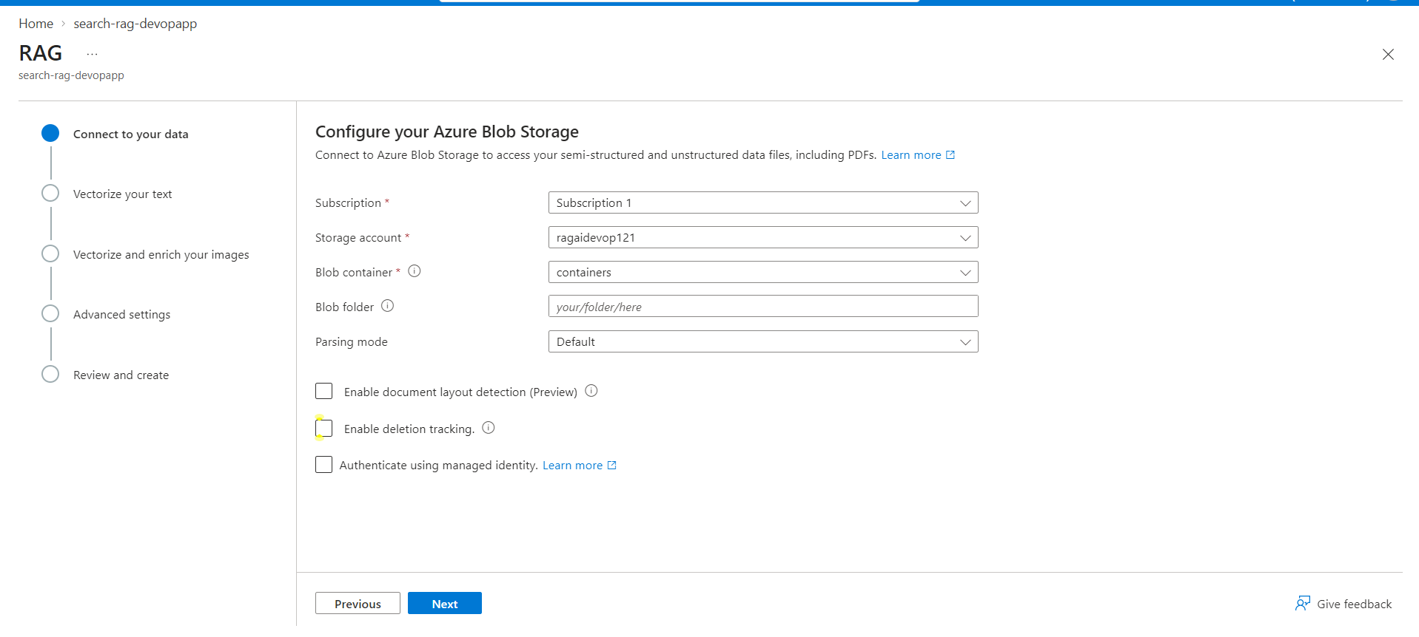
- Select the knowledge container.
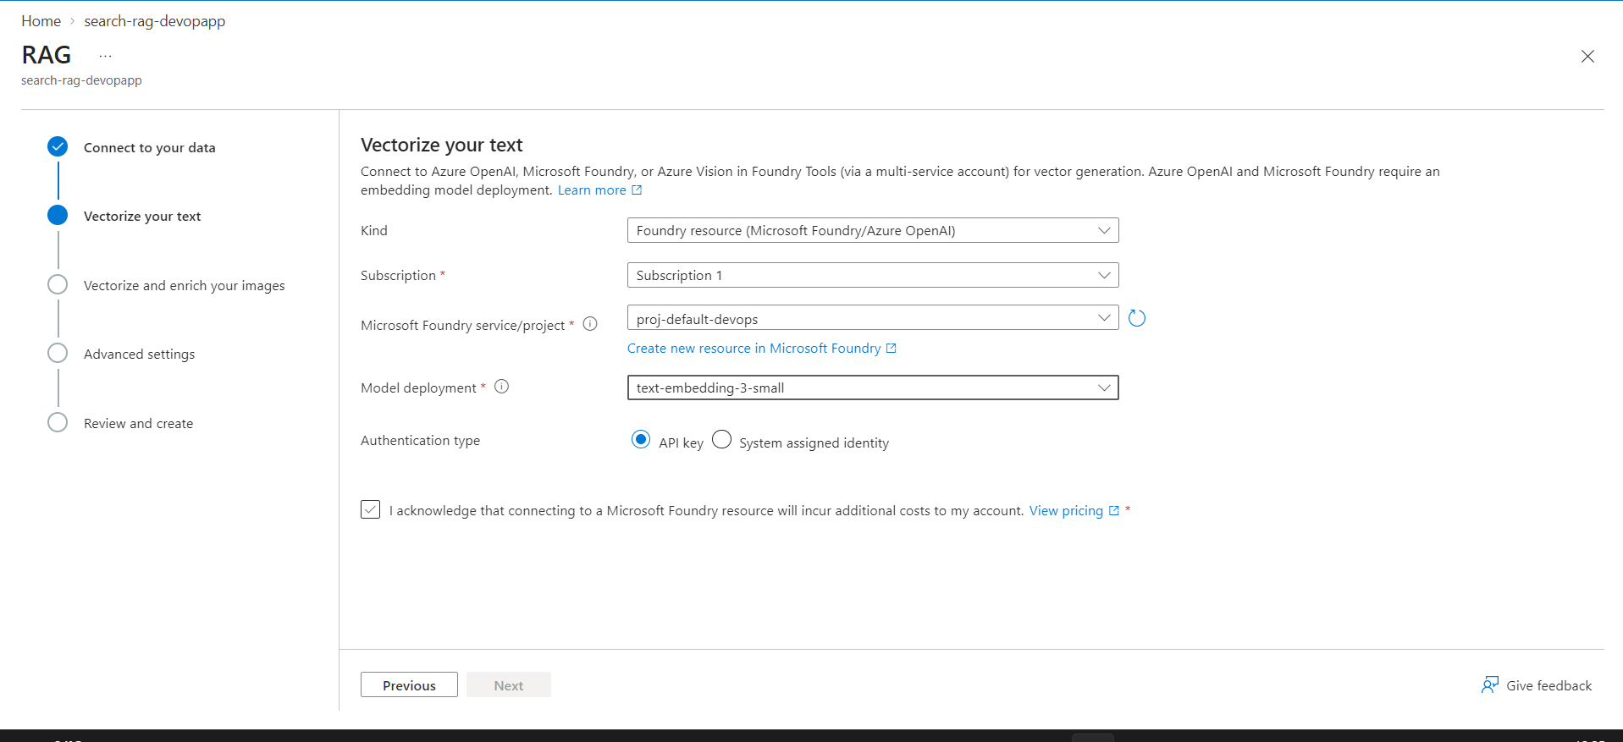

Step 2: Configure the Data Source
Configure the connection to your storage account.
Set the data source name:
Rag-knowledge-source
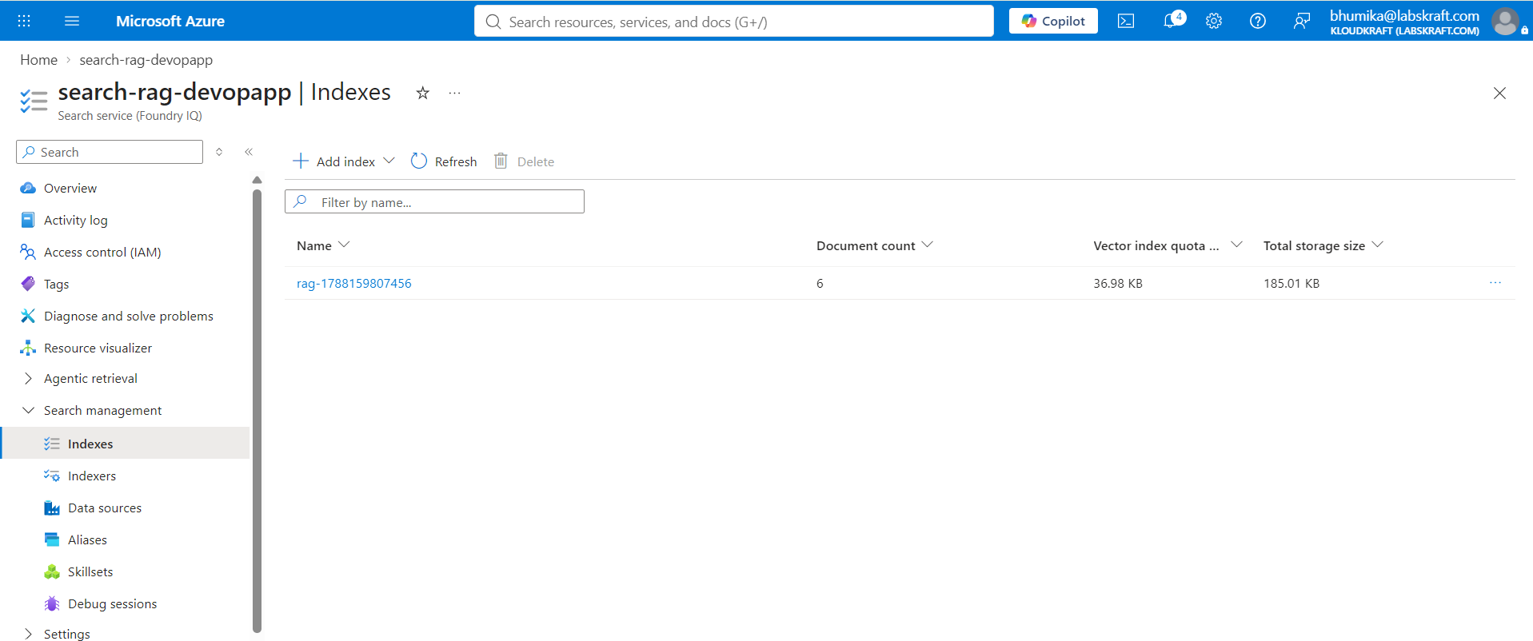
Select the appropriate authentication method provided by your lab environment.
Continue to the next step.

Step 3: Create the Search Index
Configure the index.
Example:
Index name
rag-knowledge-index
Allow the wizard to create the required searchable fields.
Enable semantic search if available in your selected configuration.
Select Create / Submit.

Lab 6 — Connect Knowledge to the AI Agent
Now we connect the search index to the AI application.

Step 1: Create an Agent
- Return to Azure AI Foundry.
- Open your project.
- Select Agents.
- Select + Create agent.
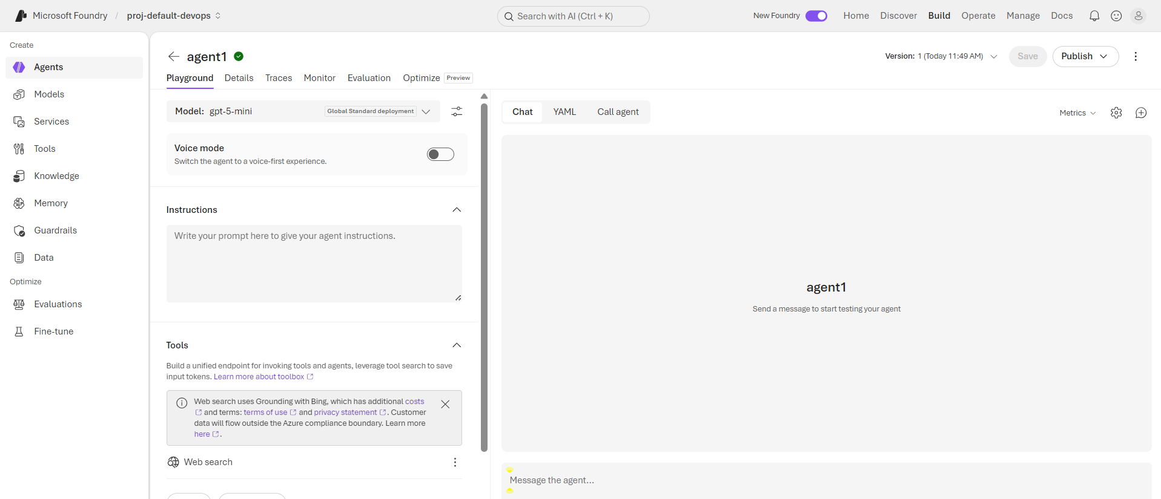
Provide:
Name:
RAG-Azure-Agent
Select your deployed GPT model.

Step 2: Add Knowledge
In the agent configuration, locate the Knowledge / Knowledge sources / Tools section.
Add your Azure AI Search resource or the knowledge source created earlier.
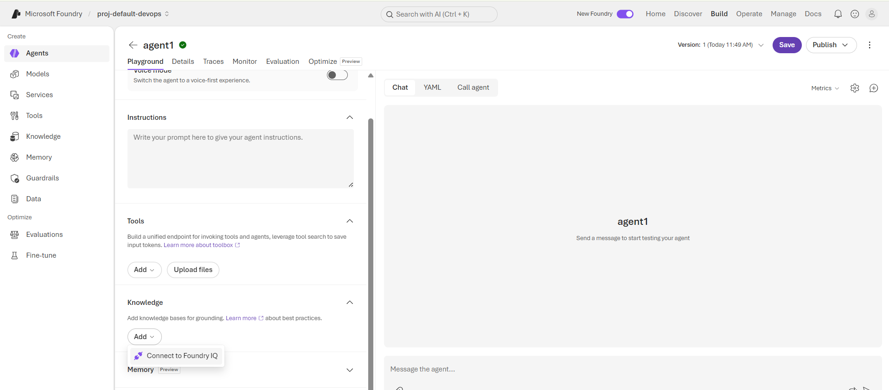
Select:
Knowledge
In left navigation :
Select ai search > connect
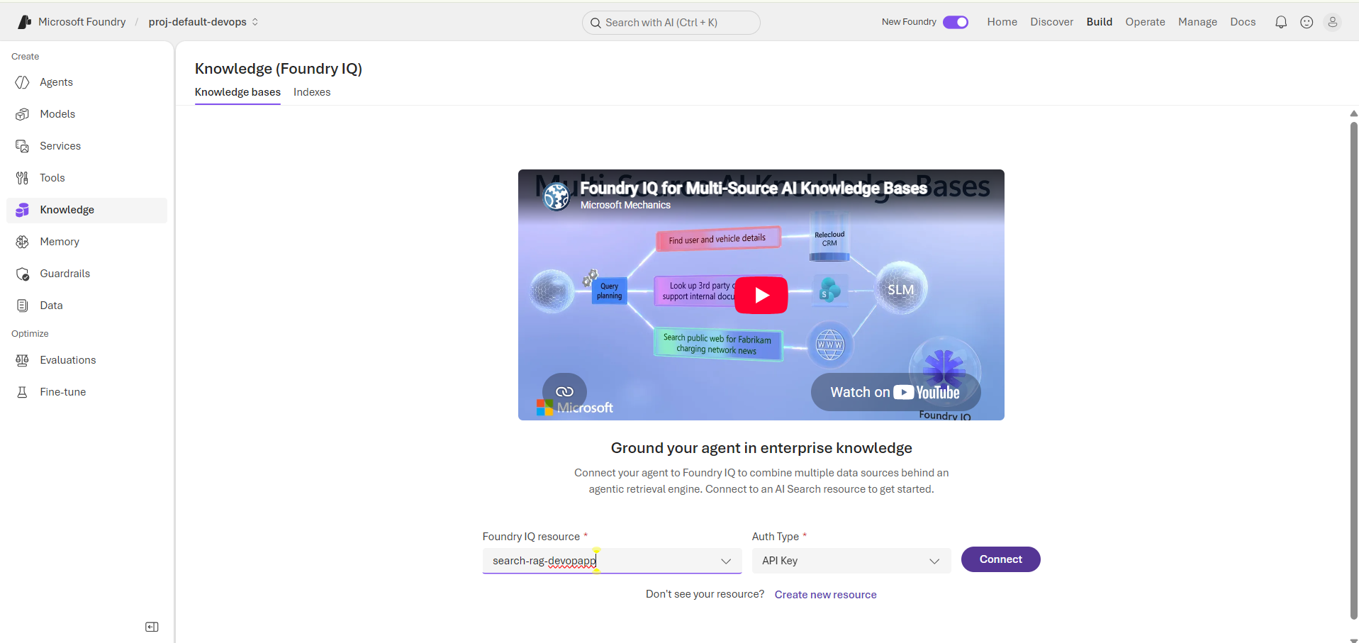
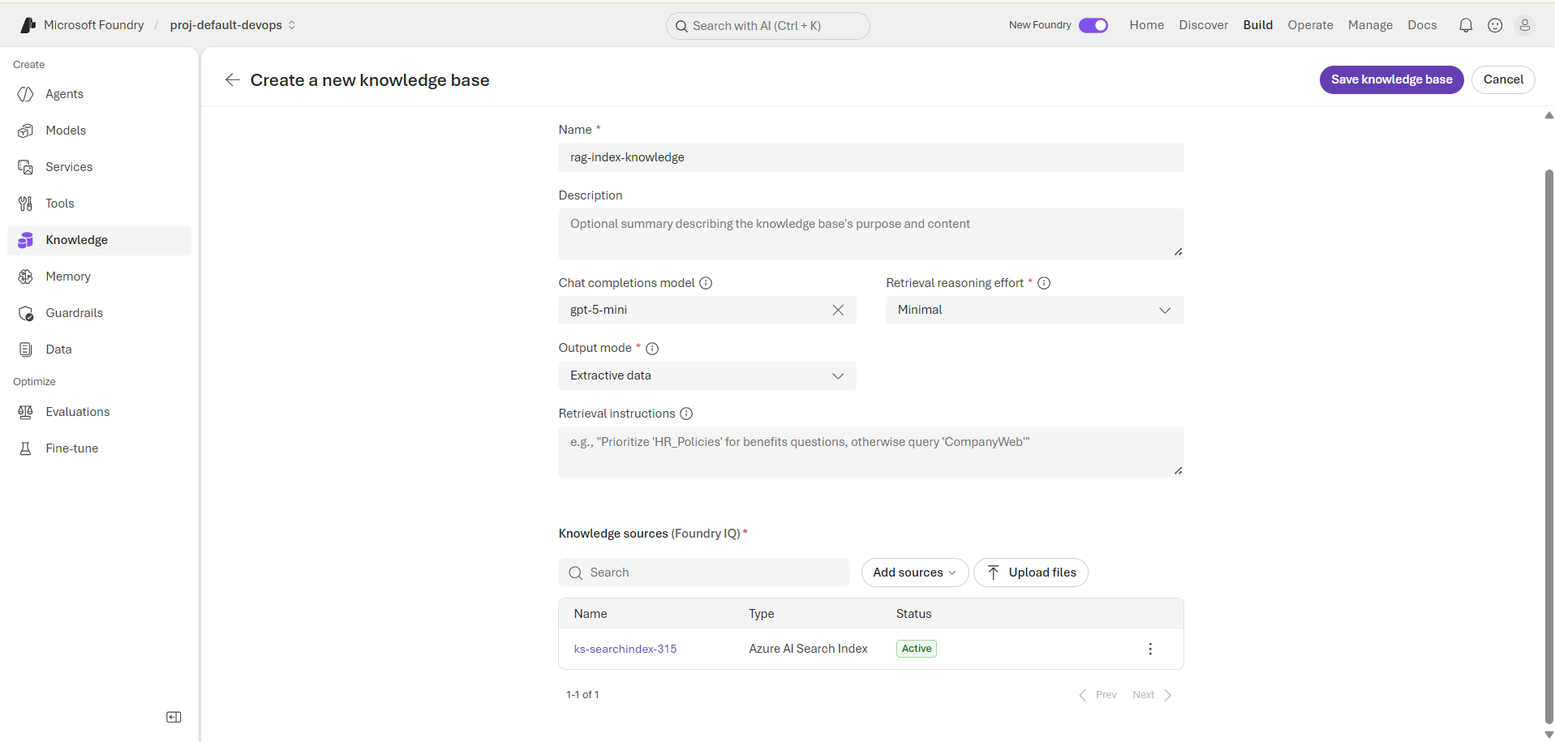
Save the configuration.

Go to Agent > knowledge source > foundry IQ
Select the knowledge source > connect
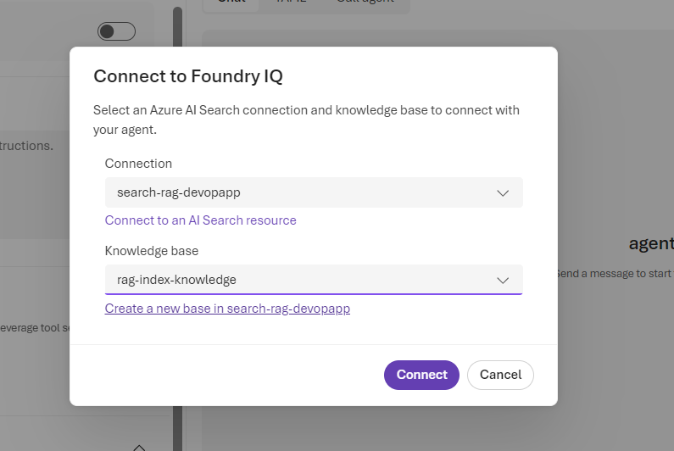
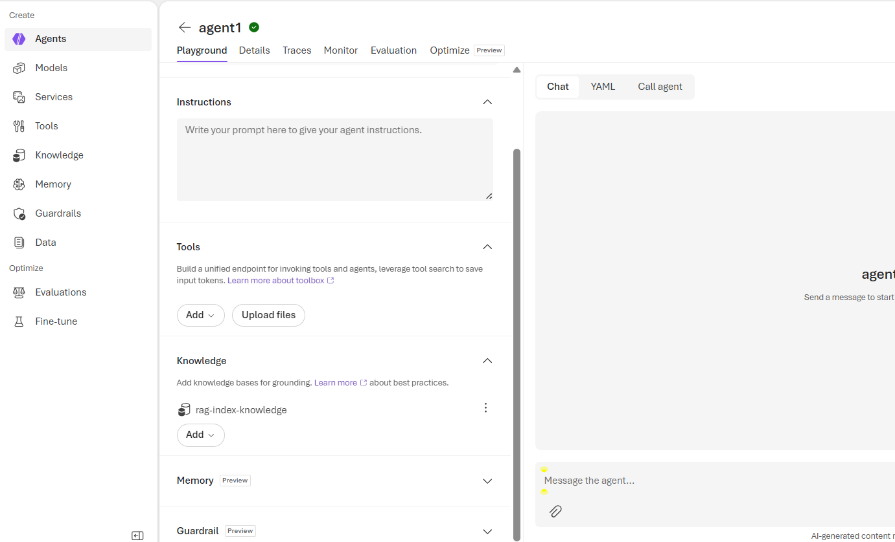

Lab 7 — Test the RAG Application
Open the agent's Playground / Test interface.
Ask a question that can be answered from your uploaded documents.
Then ask:
According to the provided knowledge, what is Retrieval Augmented Generation?
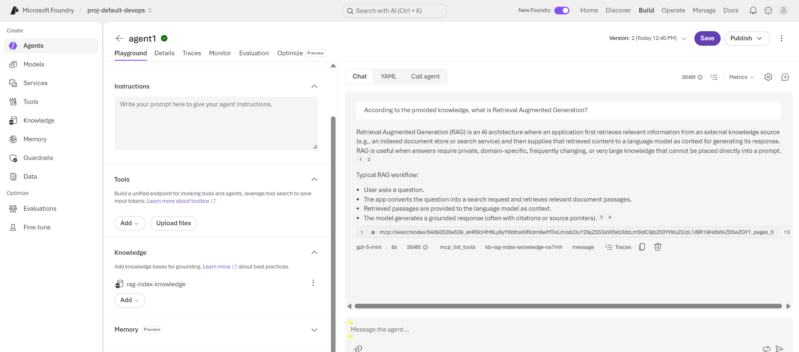
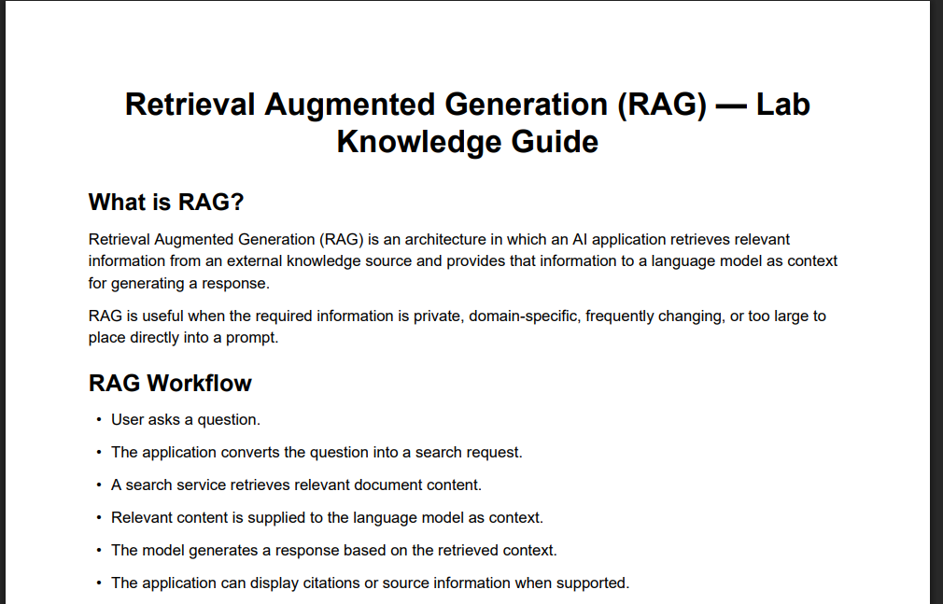
The agent should retrieve relevant information from the knowledge source before generating the response.

Test a Question Outside the Knowledge
Ask:
What is the population of Mars?
The agent should avoid confidently inventing an answer if your instructions tell it to respond only from the provided knowledge.

Lab 8 — Observe the RAG Flow
The expected flow is:
User Question
↓
AI Agent
↓
Azure AI Search
↓
Relevant document chunks
↓
GPT Model
↓
Grounded Response
Check the agent's response details/citations if available.
Look for evidence showing that the answer was generated using retrieved knowledge.

